Data Wrangling and Model Output
Phillip Smith | 7/26/2026 | sales-customer-segmentation
GitHub: https://github.com/PESIII23/customer-segmentation

Introduction
The objective of this project is to segment customers into meaningful, actionable groups that the business can target with tailored marketing campaigns. I execute an end-to-end analytical approach and apply machine learning to internal transactional sales data so the business can better understand who its customers are, how they behave, and where the greatest revenue opportunities lie.
Milestone 1 established a clean, well-understood master file and a customer-level RFM (Recency, Frequency, Monetary) table. This milestone builds on that foundation: I prepare a model input dataset, develop four iterations of clustering models, evaluate them with standard clustering performance metrics, select the best-performing technique, and use its output to band every customer as Gold, Silver, or Bronze. Because the source data is transactional rather than pre-labeled, the problem remains an unsupervised segmentation task.

Data Exploration
The dataset is a single sheet of 379,979 line-item records spanning a full calendar year (Jan 4 - Dec 9, 2021). Each row represents one product line on one invoice. Below I list each field, role, and data type.
- InvoiceNo - Unique identifier for a transaction as a string; a leading “C” denotes a cancelled order.
- StockCode - Product identifier as a string; most are five-character product codes, with a handful of service codes (POST, DOT, M, etc.).
- Description - Product name/description as a string (3,778 distinct values).
- Quantity - Number of units on the line as an integer (negative on cancellations).
- InvoiceDate - Date and time of the transaction as a datetime (2021).
- UnitPrice - Price per unit, in GBP, as a float.
- CustomerID - Unique customer identifier as an integer (4,214 distinct customers).
- Country - Country of the customer as a string (36 distinct; predominantly United Kingdom).

Original Statistical Summary
Most fields are identifiers, dates, or categorical strings that do not yield meaningful descriptive statistics. The two numeric columns, Quantity and UnitPrice, do — and they immediately reveal data-quality issues. Quantity ranges from –80,995 to 80,995, and UnitPrice includes values as low as 0. The large negative quantities correspond to cancellations, and the zero prices to non-sale adjustments; both are resolved during cleansing so that later summaries describe genuine purchasing behavior.
Attribute | Mean | Median | Std Dev | Min | 25% | 75% | Max
Quantity | 12.13 | 5.00 | 256.59 | -80,995 | 2.00 | 12.00 | 80,995
UnitPrice | 3.48 | 1.95 | 71.70 | 0.00 | 1.25 | 3.75 | 38,970
Table 1. Descriptive statistics for the raw numeric columns (before cleansing).

Data Cleansing

Missing Values
An Excel file was analyzed and a Python script was executed which detected no missing values in any of the eight columns. Critically, CustomerID is fully populated across all records, so every transaction can be attributed to a customer and no imputation is required to build the customer-level analysis.

Record Filtering
While no values are missing, several categories of records are not valid sales and would distort any measure of customer value. I removed exact duplicate rows, cancelled orders (invoice prefix “C” with negative quantity), non-product service lines (postage, manual adjustments, discounts, bank charges, and commissions), and any remaining lines with non-positive quantity or price. The clean master file retains 365,581 of 379,979 records (96.2%).
Cleansing Step | Records Removed | Records Remaining
Starting records | — | 379,979
Remove exact duplicate rows | 4,729 | 375,250
Remove cancelled orders (“C” invoices) | 8,191 | 367,059
Remove non-product service codes | 1,448 | 365,611
Remove non-positive quantity/price | 30 | 365,581
Clean master file | 14,398 total | 365,581
Table 2. Record-level cleansing audit trail.

Renamed Columns
For consistency and readability across the codebase, I standardized the column headers to uppercase, self-documenting names.
Original Header | Standardized Header
InvoiceNo | INVOICE_ID
StockCode | STOCK_CODE
Description | DESCRIPTION
Quantity | QUANTITY
InvoiceDate | INVOICE_DATE
UnitPrice | UNIT_PRICE
CustomerID | CUSTOMER_ID
Country | COUNTRY
Table 3. Column header standardization.

Data Transformation

Derived Feature: Line Revenue
I created TOTAL_PRICE = QUANTITY × UNIT_PRICE to capture the revenue contributed by each line item. This becomes the basis for the monetary component of each customer’s value.

Customer-Level Aggregation (RFM)
Because the business question is about customers, not individual line items, I aggregated the 365,581 transaction lines into one row per customer, producing a table of 4,214 customers. This is a transformation of the dataset to a different hierarchy: from a transaction grain to a customer grain. Recency is measured relative to a snapshot date of December 10, 2021 (one day after the final invoice), so the calculation is reproducible no matter when the pipeline runs.
- RECENCY - Days since the customer’s most recent purchase (lower is more recently active).
- FREQUENCY - Number of distinct invoices (purchase occasions) the customer placed.
- MONETARY - Total revenue (sum of TOTAL_PRICE) the customer generated.
- AVG_ORDER_VALUE - MONETARY ÷ FREQUENCY - average spend per purchase occasion.

Log Transformation
The RFM measures are heavily right-skewed: a small number of high-value, high-frequency customers sit far above the median. Because the segmentation relies on distance-based clustering, I added log-transformed versions (log1p) of Recency, Frequency, and Monetary to compress this skew. The log transform turns the sharply skewed Monetary distribution into an approximately normal one, which makes scaling and clustering far more stable.

Updated Statistical Summary
After cleansing, the transaction-level numeric columns describe genuine sales. Quantity and price are now strictly positive, and the extreme negatives are gone.
Attribute | Mean | Median | Std Dev | Min | 25% | 75% | Max
QUANTITY | 13.22 | 6 | 186.62 | 1 | 2 | 12 | 80,995
UNIT_PRICE | 2.86 | 1.79 | 4.23 | 0.04 | 1.25 | 3.75 | 649.5
TOTAL_PRICE | 22.35 | 12.3 | 320.97 | 0.06 | 4.95 | 19.8 | 168,469.6
Table 4. Descriptive statistics for cleaned transaction-level numeric attributes.
At the customer level, the RFM table summarizes each customer’s behavior. The gap between the mean and median of Frequency and Monetary confirms the right-skew that motivates the log transform.
Attribute | Mean | Median | Std Dev | Min | 25% | 75% | Max
RECENCY | 84.93 | 48 | 90.2 | 1 | 17 | 128 | 340
FREQUENCY | 4.04 | 2 | 7.04 | 1 | 1 | 4 | 185
MONETARY | 1,939.26 | 654.21 | 8,587.73 | 3.75 | 301.38 | 1,582.75 | 270,561.14
AVG_ORDER_VALUE | 420.39 | 294.18 | 1,826.35 | 3.75 | 177.8 | 430 | 84,236.25
Table 5. Descriptive statistics for customer-level RFM attributes (4,214 customers).

Exploratory Data Analysis

Numerical Attributes
Customer Recency is right-skewed: a large group of customers purchased within the last one-to-two months, followed by a long tail of dormant customers who last purchased 150–340 days ago. This dormant tail is precisely the population a win-back campaign would target.
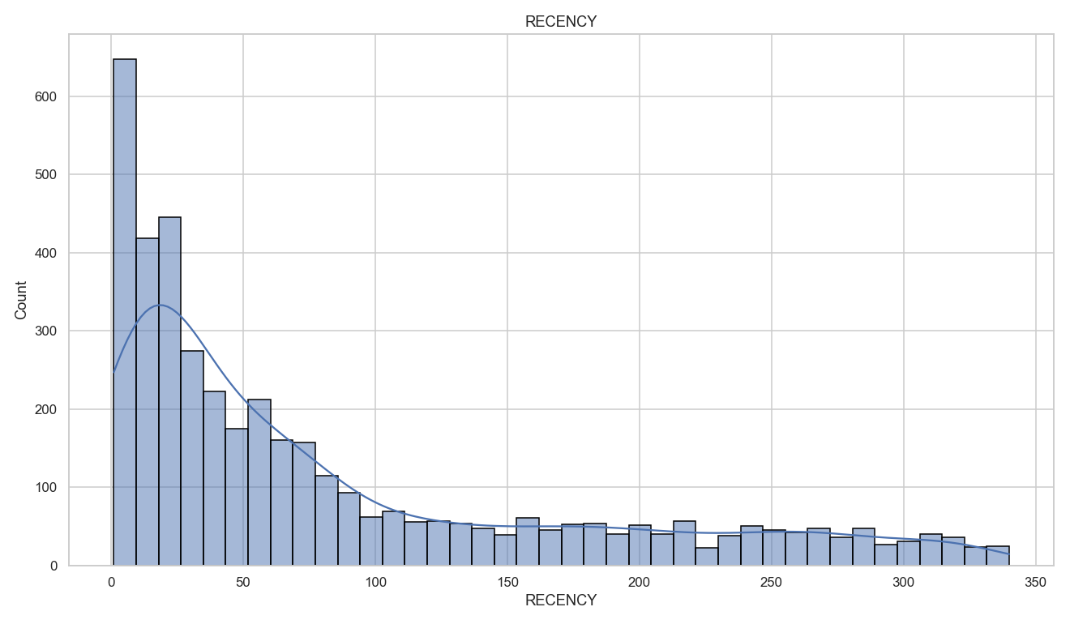
Figure 1. Distribution of customer Recency (days since last purchase).
Frequency is even more concentrated: the median customer places just two orders, while a small cohort of loyal buyers orders dozens of times. These frequent buyers are strong candidates for loyalty or referral programs.
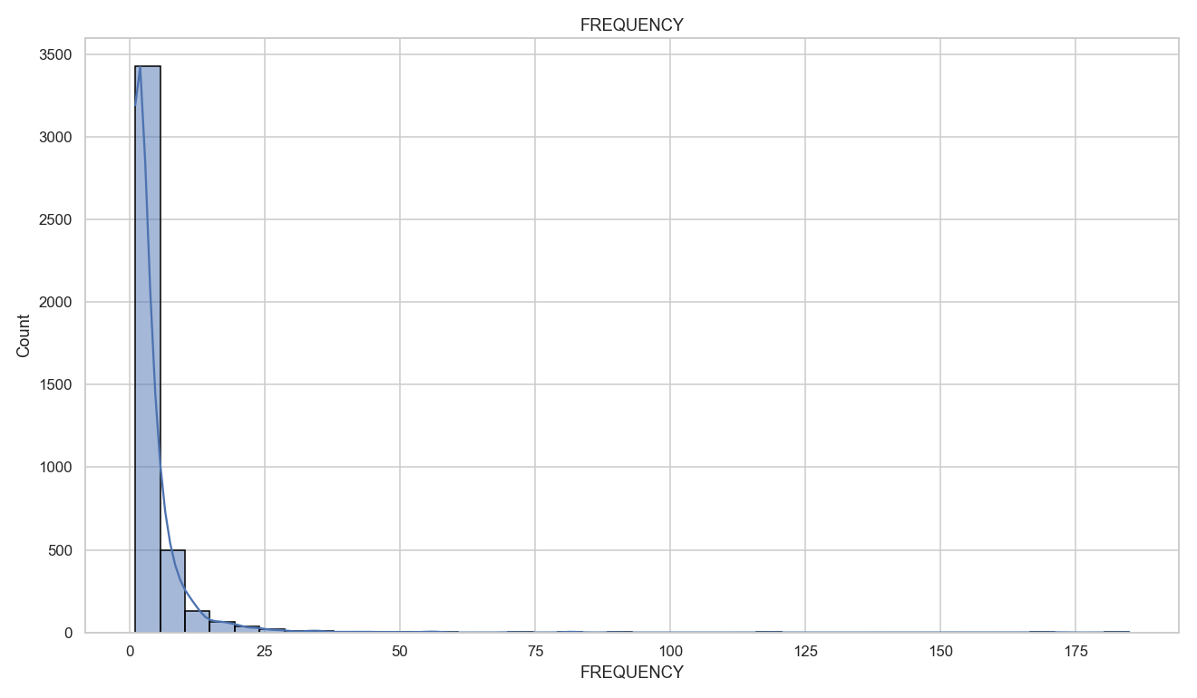
Figure 2. Distribution of customer Frequency (distinct invoices).
Monetary value shows the most extreme skew of all: raw spend is compressed against zero with a handful of customers spending into the hundreds of thousands. Applying a log transform produces an approximately normal distribution — the justification for log-scaling before clustering.
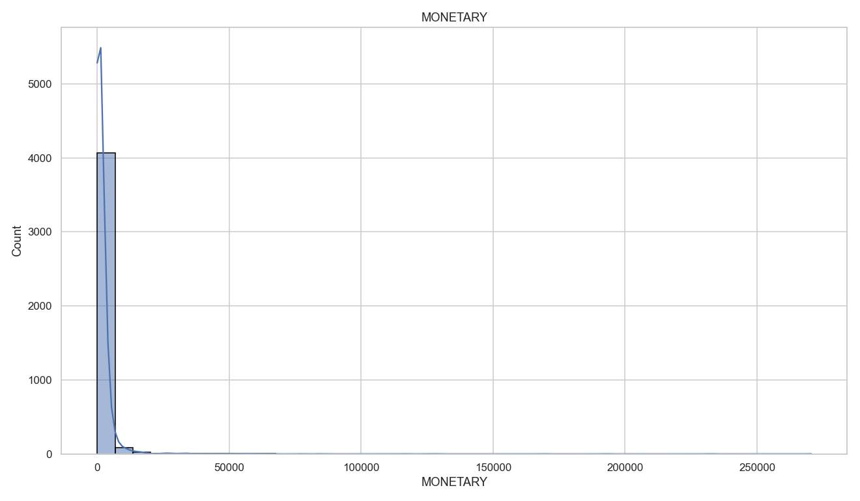
Figure 3. Raw Monetary distribution - severely right-skewed.
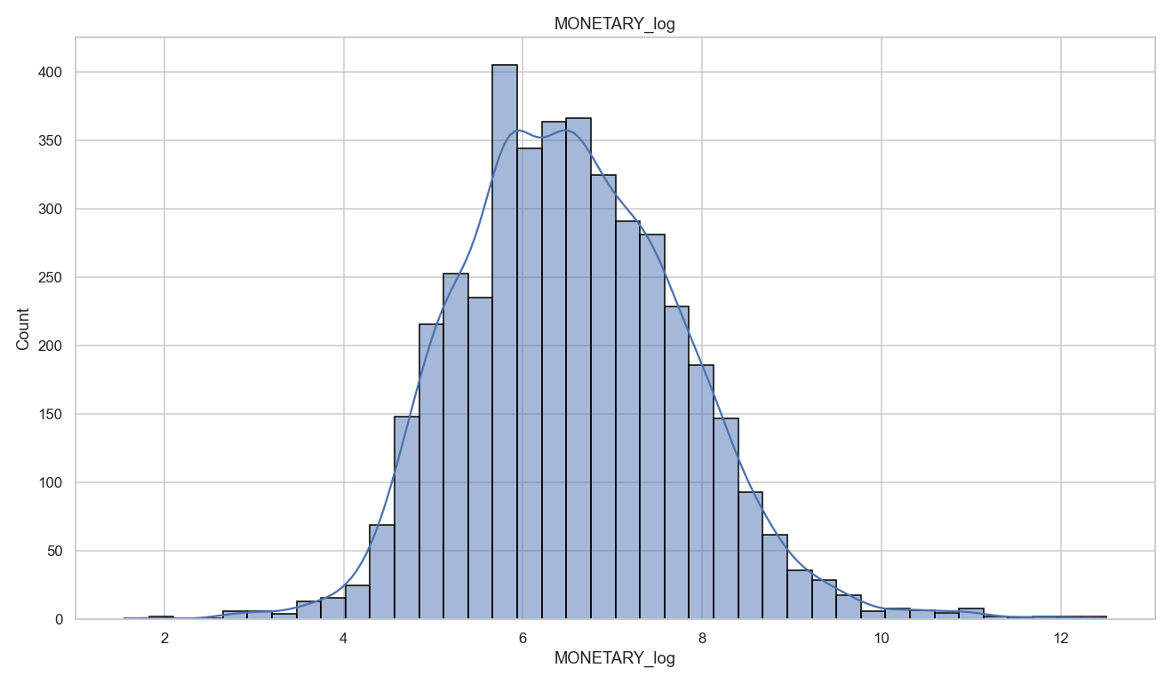
Figure 4. Log-transformed Monetary distribution - approximately normal.

Categorical & Profiling Metrics
Profiling the categorical and identifier attributes clarifies the shape of the data. There are 17,008 distinct invoices across 4,214 customers and 3,590 distinct products, sold into 36 countries. The market is overwhelmingly domestic: the United Kingdom accounts for 89% of all line items, so any segmentation and campaign design should treat the UK as the core market and international customers as a distinct, smaller opportunity.
Attribute | Distinct | Most Frequent Value | Count | % Rows
INVOICE_ID | 17,008 | 576339 | 541 | 0.1
STOCK_CODE | 3,590 | 85123A | 1,816 | 0.5
DESCRIPTION | 3,778 | WHITE HANGING HEART T-LIGHT HOLDER | 1,809 | 0.5
CUSTOMER_ID | 4,214 | 17841 | 7,381 | 2
COUNTRY | 36 | United Kingdom | 325,444 | 89
Table 6. Profiling metrics for categorical and identifier attributes.
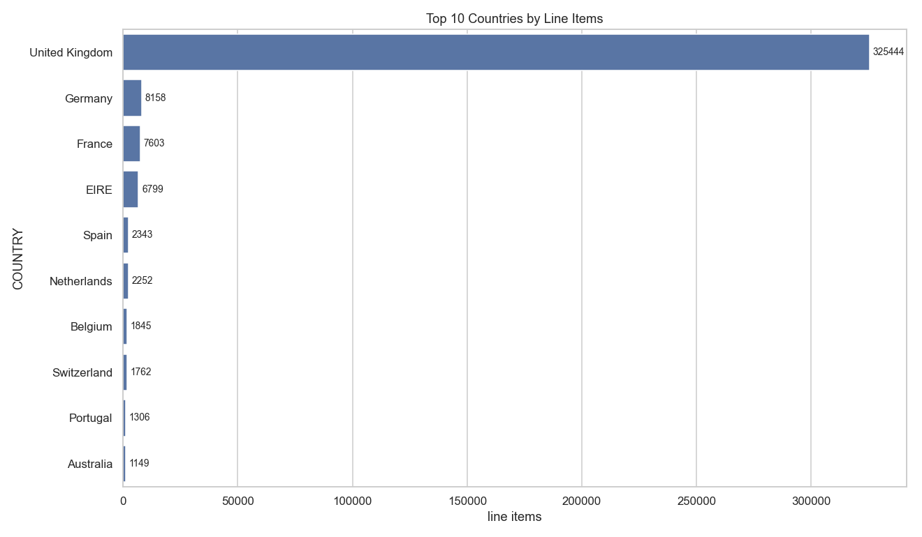
Figure 5. Top 10 countries by line-item volume; the United Kingdom dominates at 89%.
The product mix is classic gift and homeware retail - decorative t-light holders, cake stands, and printed lunch bags lead by volume - which is consistent with the strong end-of-year seasonality below.
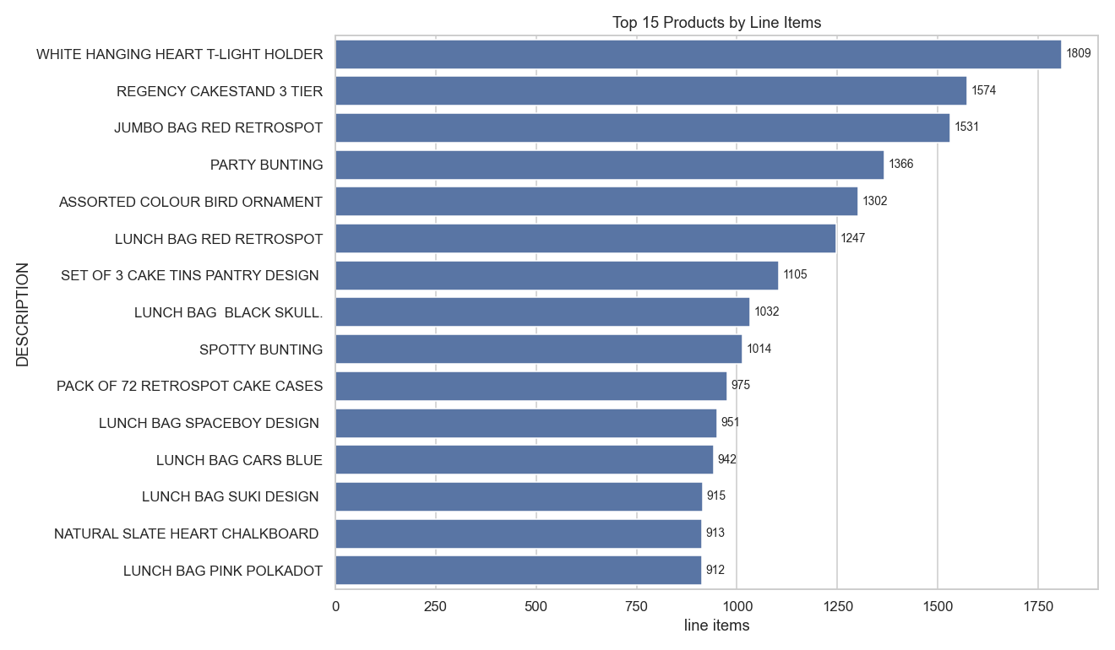
Figure 6. Top 15 products by line-item volume.
Monthly revenue reveals pronounced fourth-quarter seasonality: revenue climbs sharply from September and peaks in November before the (partial) December, more than doubling the February trough. Campaign timing should account for this holiday-driven cycle. Note that December is a partial month — the data ends on December 9 — so its apparent decline is an artifact of coverage, not a real drop in demand.
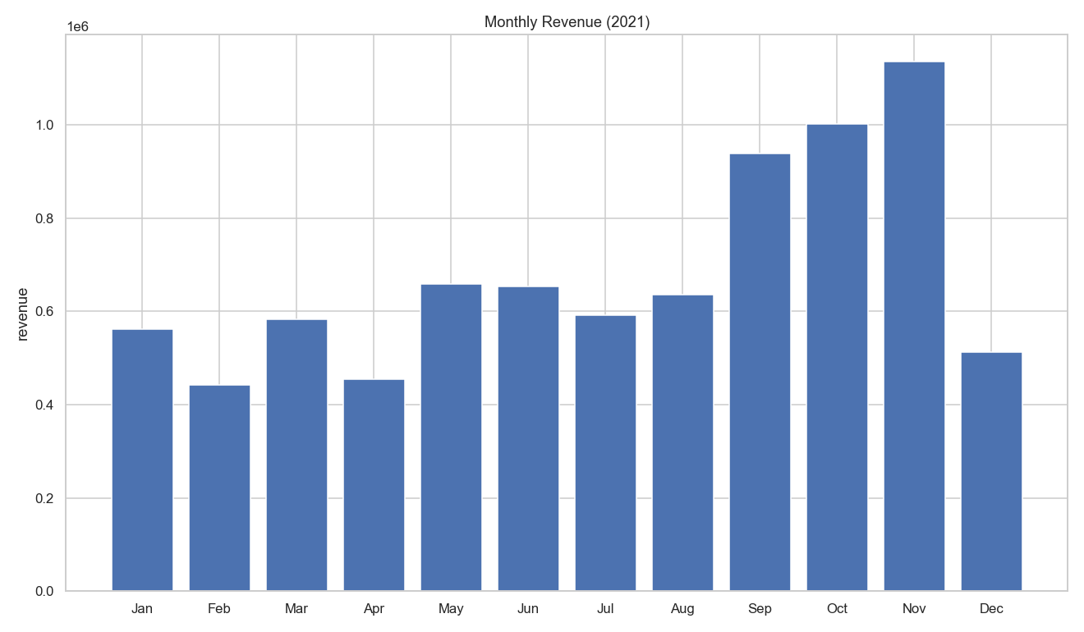
Figure 7. Monthly revenue across 2021.

Correlation Matrix
The Pearson correlation matrix over the RFM features confirms that each behavioral axis carries distinct information. Frequency and Monetary are moderately, positively correlated (0.55) - customers who order more often also spend more overall. Recency is negatively related to both Frequency (-0.27) and Monetary (-0.12): customers who purchased recently tend to be the more frequent, higher-spending ones. Average Order Value is largely independent of Frequency (0.02) and Recency (0.01) and only moderately tied to Monetary (0.41). Because no pair of features is so strongly correlated as to be redundant, all three RFM dimensions are retained for segmentation.
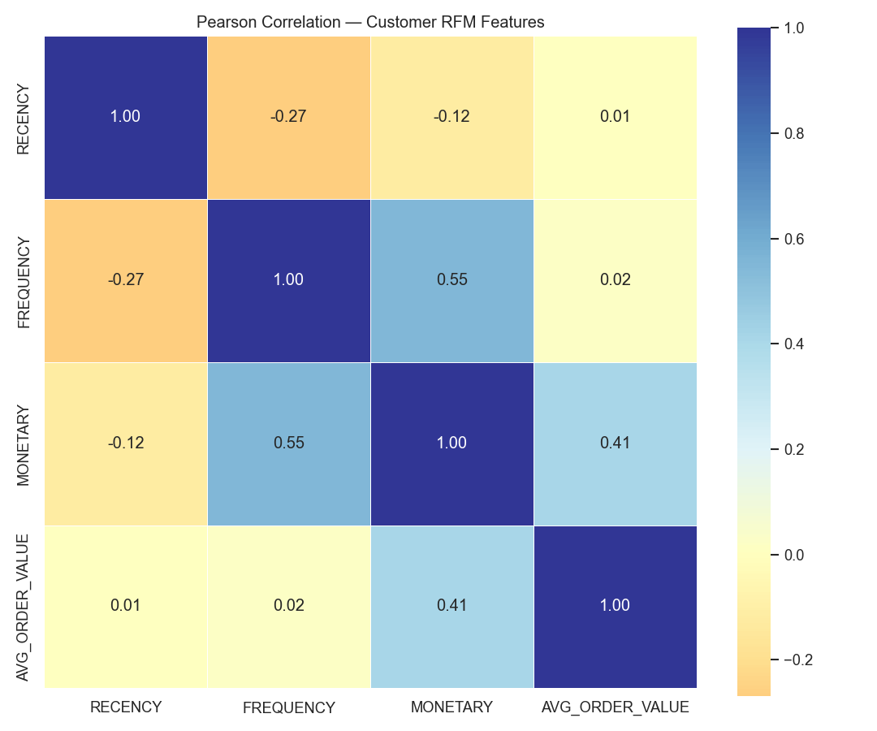
Figure 8. Pearson correlation matrix of customer RFM features.

Model Input Preparation
The clustering algorithms need every customer described on one comparable scale. Raw Recency, Frequency, and Monetary are measured in different units (days, counts, GBP) and span wildly different ranges, so feeding them in directly would let Monetary dominate every distance calculation. I therefore built three additional representations of the same behaviors.

RFM Ratings (model input)
Following the reference approach, each customer is ranked against every other customer on each behavior, converted to a percentile, and multiplied by 5 to produce a 0–5 rating. Recency is ranked descending, so a higher rating always means a better customer on all three axes. These three ratings — RECENCY_RATING, FREQUENCY_RATING, MONETARY_RATING — are the multivariate representation actually fed to the models. Because ranking places all three on an identical 0–5 scale, no further standardization is required, and the extreme outliers that motivated the log transform are compressed automatically.

RFM Quartile Scores (proxy variable)
Each behavior is also cut into quartiles and scored 1–4, with Recency reversed so 4 is always the better customer. Summing the three gives RFM_SCORE, an interpretable 3–12 proxy for overall customer value. This score is not used to fit the models; it is used afterwards to rank the discovered clusters so the Gold / Silver / Bronze assignment is driven by measured value rather than by arbitrary cluster numbering. Frequency is tie-heavy (the median customer places only two orders), so it is ranked before binning to keep the quartile edges unique.

Dummy and Proxy Variables
- IS_UK - a one-hot dummy flagging United Kingdom customers, derived from the Country field. It is carried alongside the model input so each finished segment can be profiled by home market.
- Q4_SPEND_SHARE - a trend proxy giving the share of each customer’s total spend that falls in the September-December holiday peak identified during EDA. It quantifies how seasonal an individual customer is, which informs campaign timing.
Both are deliberately excluded from the clustering feature matrix. The segmentation is meant to describe purchasing behavior, and adding a geography dummy would let the model split customers on where they live rather than on how much they are worth.

Modeling Iterations
I built four iterations of clustering models, each a different technique run across a parameter sweep, for 55 fitted models in total. Every model was scored with the same three cluster-validity metrics so the comparison is like-for-like.

Iteration 1 — K-Means
Hypothesis: customer value forms compact, roughly spherical groups in RFM rating space, which is exactly the structure K-Means is built to find. I swept k from 1 to 12 and captured the sum of squared errors (SSE) at each step to apply the elbow method.
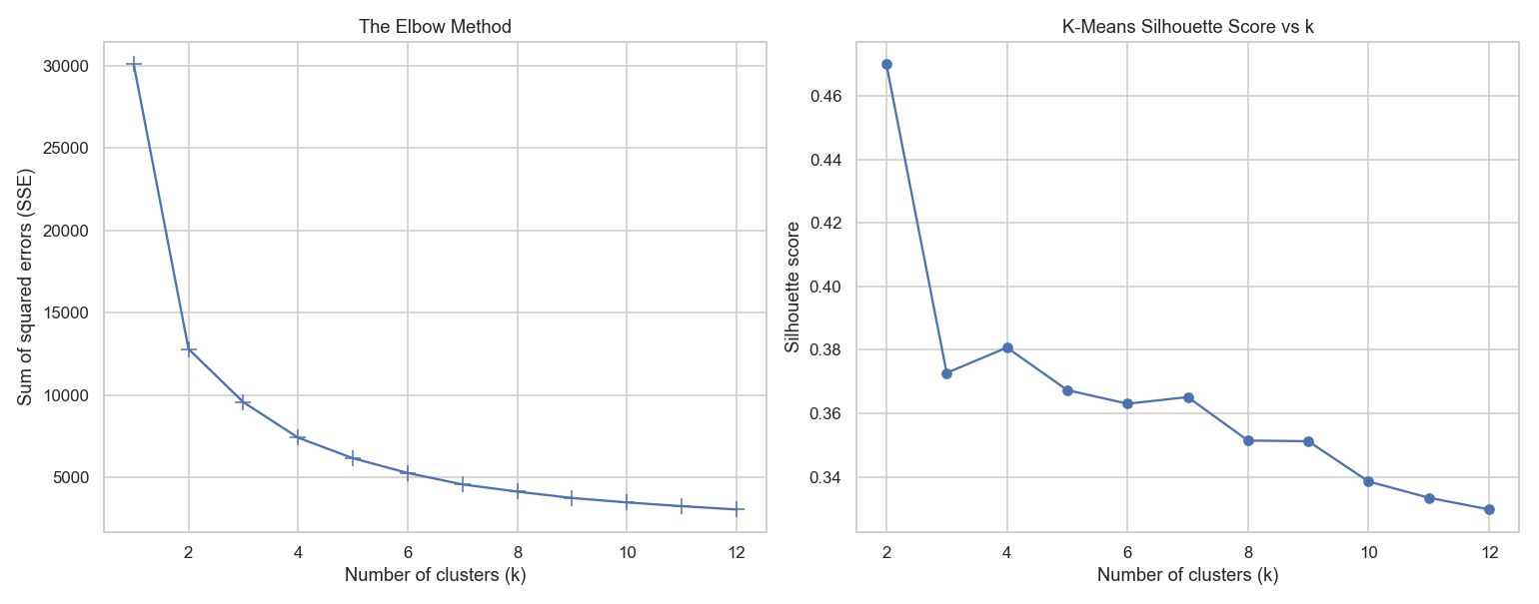
Figure 9. Elbow method (left) and silhouette score by k (right) for the K-Means sweep.
The elbow curve bends sharply between k=2 and k=4 and flattens thereafter, indicating that additional clusters past roughly four bring diminishing returns in error reduction. The silhouette curve tells a complementary story: k=2 scores highest at 0.470, but two clusters cannot express three customer tiers. Within the usable range, k=4 is the clear local maximum at 0.381 — higher than k=3 (0.373) and every larger k.
k | SSE | Silhouette | Calinski-Harabasz | Davies-Bouldin
2 | 12,794 | 0.4699 | 5,692.4 | 0.8079
3 | 9,564.9 | 0.3727 | 4,517 | 1.0538
4 | 7,407.2 | 0.3807 | 4,296.5 | 0.97
5 | 6,157.1 | 0.3673 | 4,089.3 | 1.012
6 | 5,261.7 | 0.363 | 3,970.4 | 0.9404
7 | 4,568 | 0.3651 | 3,916.7 | 0.9175
8 | 4,130.5 | 0.3514 | 3,775.6 | 0.9788
Table 7. K-Means sweep results, k=2 to k=8.

Iteration 2 — Mean Shift
Hypothesis: rather than fixing the number of clusters in advance, let the data decide. Mean Shift finds modes in the density of the rating space, so the cluster count falls out of the bandwidth parameter. I swept bandwidth from 0.5 to 1.6. Bandwidths of 1.4 and above converged on a stable three-cluster solution, with the best silhouette of 0.371 at bandwidth 1.6 — closely comparable to K-Means but slightly lower. Narrower bandwidths fragmented the data into dozens of tiny clusters that carry no business meaning.

Iteration 3 — DBSCAN
Hypothesis: a density-based method might isolate the dense core of ordinary customers while flagging unusual ones as noise. I swept epsilon from 0.20 to 0.35 and min_samples from 5 to 45. DBSCAN performed poorly here: its best configuration (eps=0.35, min_samples=5) reached a silhouette of only 0.209 while labeling 132 customers as noise, and its Davies-Bouldin score of 5.51 was more than five times worse than K-Means. Many configurations produced negative silhouette scores, meaning points were closer to a neighbouring cluster than their own. RFM ratings are close to uniformly distributed by construction, so there are no genuine density gaps for DBSCAN to exploit. This iteration is a documented dead end rather than a candidate.

Iteration 4 — Agglomerative (Ward)
Hypothesis: hierarchical linkage builds clusters bottom-up and may find nested value structure that K-Means’ spherical bias misses. I swept the cluster count from 2 to 12 using Ward linkage. Agglomerative tracked K-Means closely but sat consistently below it — 0.342 at three clusters against K-Means’ 0.381 at four — confirming the K-Means result without improving on it.

Model Evaluation and Selection
Each model was evaluated on three standard clustering performance metrics. Silhouette (–1 to 1, higher is better) measures how much closer each point sits to its own cluster than to the next nearest. Calinski-Harabasz (higher is better) is the ratio of between-cluster to within-cluster dispersion. Davies-Bouldin (lower is better) measures average similarity between each cluster and its most similar neighbour.
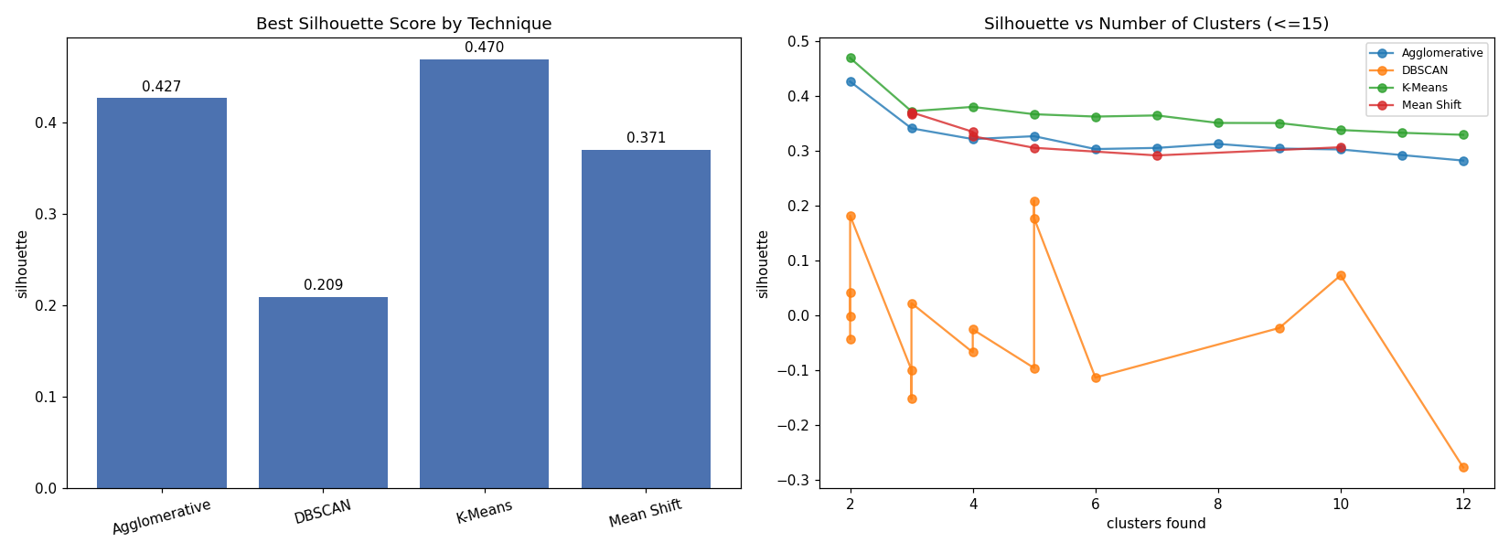
Figure 10. Best silhouette by technique (left) and silhouette against cluster count (right).
Technique | Best Parameters | Clusters | Silhouette | Calinski-Harabasz | Davies-Bouldin
K-Means | k=4 | 4 | 0.3807 | 4296.5 | 0.97
Mean Shift | bandwidth=1.6 | 3 | 0.3708 | 4463.8 | 1.0275
Agglomerative | k=3 | 3 | 0.3416 | 3932.8 | 1.0962
DBSCAN | eps=0.35, min_samples=5 | 5 | 0.2095 | 1884.1 | 5.5095
Table 8. Best configuration per technique, restricted to solutions of 3 to 8 clusters.
K-Means at k=4 wins on all three metrics simultaneously: the highest silhouette (0.381), the highest Calinski-Harabasz (4,296.5), and the lowest Davies-Bouldin (0.970). Because the metrics agree, the selection is not an artifact of choosing a favourable one. I therefore selected K-Means with k=4 as the final model.

Reflection and Refinement
Reviewing the first iteration raised a legitimate concern: silhouette peaks at k=2, so a purely mechanical reading of the metric would pick two clusters. I rejected that reading on analytical grounds rather than convenience. Two clusters cannot express the three tiers the business requires, and a two-way split collapses the distinction between a genuinely lapsed customer and a merely occasional one — which are the two groups needing the most different campaigns. Constraining the search to solutions of three or more clusters and re-selecting produced k=4, which is also where the elbow curve flattens. Two independent criteria agreeing on the same answer is stronger evidence than either alone.
A second refinement followed from that choice. k=4 produces four clusters but the business needs three bands, so the two middle clusters are merged into Silver — the same approach the reference solution takes. This is defensible because the two middle clusters differ mainly in recency (mean 99 days versus 25 days) while sitting at similar spend levels; both are mid-value customers, and both warrant the same class of nurture campaign.
Finally, I validated that the chosen model is not overfitting the specific customers it was fit on. Refitting K-Means with k=4 on a random 80% training sample and scoring the held-out 20% produced a silhouette of 0.3823, compared with 0.3807 on the full population. The scores are effectively identical, so the cluster structure generalizes to customers the model has never seen. All randomized steps use random_state = 42, so every result in this document reproduces exactly.

Customer Segmentation: Gold, Silver, and Bronze
The final model assigns every one of the 4,214 customers to one of four clusters. To convert those into business tiers, the clusters are ranked by their mean RFM_SCORE: the highest-scoring cluster becomes Gold, the lowest becomes Bronze, and the remainder collapse into Silver. The banding is therefore driven by measured customer value, not by the arbitrary integer K-Means happens to assign.
Cluster | Band | Customers | Mean Recency | Mean Frequency | Mean Monetary | Mean RFM Score
0 | Gold | 1,270 | 17.2 | 9.10 | 4,893.64 | 10.93
1 | Silver | 1,014 | 99.1 | 2.99 | 1,277.99 | 7.56
3 | Silver | 769 | 25.0 | 1.50 | 386.57 | 6.75
2 | Bronze | 1,161 | 186.3 | 1.09 | 313.48 | 4.20
Table 9. Mapping of the four K-Means clusters to three business bands.
Segment | Customers | % Customers | Mean Recency | Mean Frequency | Mean Monetary | % Revenue | ARPC
Gold | 1,270 | 30.1 | 17.2 | 9.1 | 4,893.64 | 76.1 | 4,893.64
Silver | 1,783 | 42.3 | 67.2 | 2.35 | 893.52 | 19.5 | 893.52
Bronze | 1,161 | 27.6 | 186.3 | 1.09 | 313.48 | 4.5 | 313.48
Table 10. Value profile of the three customer segments.
The segmentation reveals a textbook concentration of value. Gold customers are 30.1% of the base but generate 76.1% of revenue — GBP 6.21M of the GBP 8.17M total — buying 9.1 times a year with a last purchase just 17 days ago. Bronze customers are 27.6% of the base and contribute 4.5% of revenue, having bought once on average and not returned for roughly six months. Silver sits between them at 42.3% of customers and 19.5% of revenue.
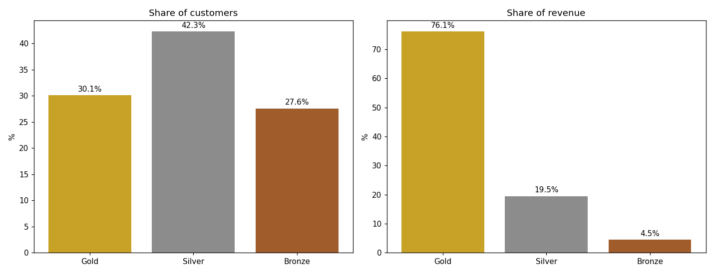
Figure 11. Share of customers versus share of revenue by segment.
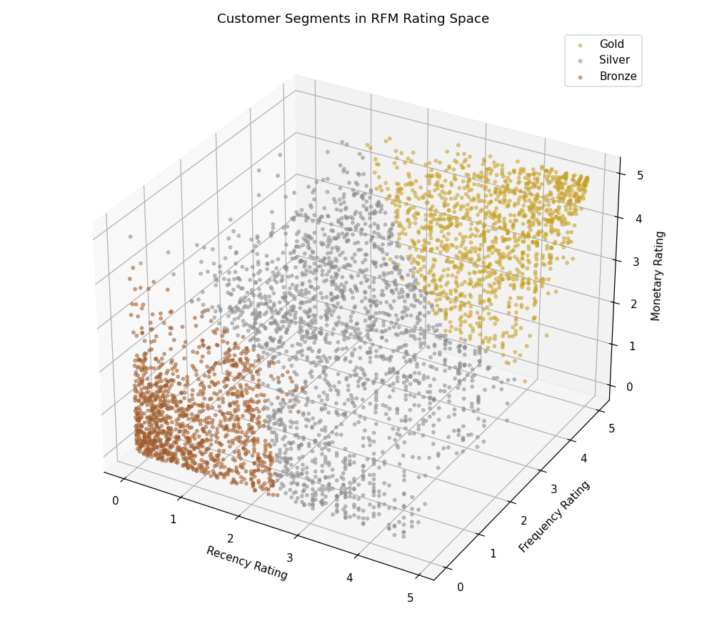
Figure 12. The three segments in the RFM rating space the model clustered on.
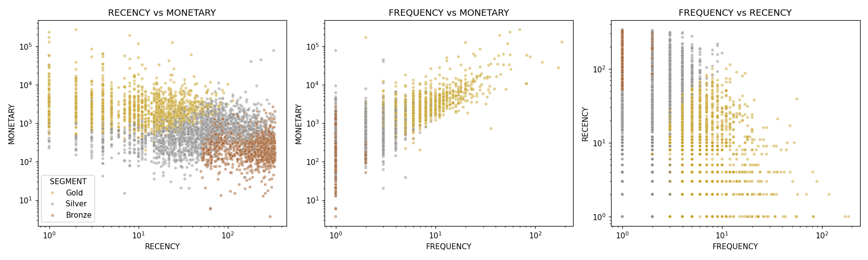
Figure 13. Segments projected onto the raw RFM planes (log scales).
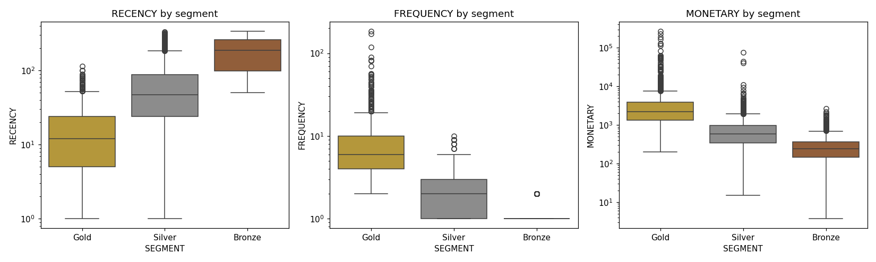
Figure 14. Distribution of each raw RFM behavior by segment (log scale).
The boxplots confirm the bands separate cleanly on all three behaviors, with the sharpest separation on Frequency and Monetary and a clear recency gradient from Gold (17 days) through Silver (67 days) to Bronze (186 days). Segment composition is also stable across geography: each band is 89-91% UK, confirming that the model split customers on behavior rather than on where they live. The Q4 spend-share proxy shows Gold and Silver concentrating roughly half their annual spend in the September-December window, against 25% for Bronze — useful input for campaign timing in the next milestone.

Model Output and Code
Running python3 -m src.pipeline executes all six stages end to end and regenerates every table and figure in this document. Stage 6 adds the modeling work and writes the following artifacts:
- src/data/processed/customer_segments.csv / .parquet - all 4,214 customers with their RFM measures, ratings, scores, cluster, and Gold/Silver/Bronze band.
- docs/tables/model_iterations.csv - every one of the 55 fitted models with its parameters and metrics.
- docs/tables/segment_profile.csv - the segment value profile reproduced above.
- docs/modeling/ - the six figures presented in this section.
The core modeling code is reproduced below; the complete module is in the repository at src/modeling/clustering.py.
def build_rfm_ratings(rfm: pd.DataFrame, transactions: pd.DataFrame) -> pd.DataFrame:
"""Rank customers on each RFM behaviour and rescale to a 0-5 rating.
Ratings put R, F and M on one comparable scale, so no further standardization
is needed before distance-based clustering. Recency is ranked descending
because fewer days since purchase is the better customer.
"""
df = rfm.copy()
bins = 5.0
df["RECENCY_RATING"] = df["RECENCY"].rank(method="min", pct=True, ascending=False) * bins
df["FREQUENCY_RATING"] = df["FREQUENCY"].rank(method="min", pct=True, ascending=True) * bins
df["MONETARY_RATING"] = df["MONETARY"].rank(method="min", pct=True, ascending=True) * bins
# Quartile scores 1-4 give an interpretable RFM_SCORE used to rank the
# clusters when banding them Gold / Silver / Bronze.
df["R_SCORE"] = pd.qcut(df["RECENCY"], 4, labels=[4, 3, 2, 1]).astype(int)
df["F_SCORE"] = pd.qcut(df["FREQUENCY"].rank(method="first"), 4, labels=[1, 2, 3, 4]).astype(int)
df["M_SCORE"] = pd.qcut(df["MONETARY"], 4, labels=[1, 2, 3, 4]).astype(int)
df["RFM_SCORE"] = df[["R_SCORE", "F_SCORE", "M_SCORE"]].sum(axis=1)
# Dummy/proxy variables carried through for segment profiling.
country = transactions.groupby("CUSTOMER_ID")["COUNTRY"].first()
df["COUNTRY"] = df["CUSTOMER_ID"].map(country)
df["IS_UK"] = (df["COUNTRY"] == "United Kingdom").astype(int)
q4_spend = (transactions[transactions["INVOICE_DATE"].dt.month >= 9]
.groupby("CUSTOMER_ID")["TOTAL_PRICE"].sum())
df["Q4_SPEND_SHARE"] = (df["CUSTOMER_ID"].map(q4_spend).fillna(0) / df["MONETARY"]).round(4)
return df
# ---- evaluation ------------------------------------------------------------
def evaluate(X: pd.DataFrame, labels: np.ndarray) -> dict:
"""Cluster-validity metrics. Undefined for a single cluster, so guard for it."""
n_clusters = len(set(labels) - {-1}) # -1 is DBSCAN noise
if n_clusters < 2:
return {"n_clusters": n_clusters, "silhouette": np.nan,
"calinski_harabasz": np.nan, "davies_bouldin": np.nan}
return {
"n_clusters": n_clusters,
"silhouette": round(float(silhouette_score(X, labels)), 4),
"calinski_harabasz": round(float(calinski_harabasz_score(X, labels)), 1),
"davies_bouldin": round(float(davies_bouldin_score(X, labels)), 4),
}
# ---- the four modeling iterations ------------------------------------------
def run_kmeans(X: pd.DataFrame, k_values=range(1, 13)) -> pd.DataFrame:
"""Iteration 1 — K-Means across k, capturing SSE for the elbow method."""
rows = []
for k in k_values:
model = KMeans(n_clusters=k, n_init=10, random_state=RANDOM_STATE).fit(X)
rows.append({"algorithm": "K-Means", "parameter": f"k={k}", "k": k,
"sse": round(model.inertia_, 1), **evaluate(X, model.labels_)})
return pd.DataFrame(rows)
def run_meanshift(X: pd.DataFrame, bandwidths=np.arange(0.5, 1.7, 0.1)) -> pd.DataFrame:
"""Iteration 2 — Mean Shift, which infers cluster count from bandwidth."""
rows = []
for bw in bandwidths:
model = MeanShift(bandwidth=bw).fit(X)
rows.append({"algorithm": "Mean Shift", "parameter": f"bandwidth={bw:.1f}",
"k": np.nan, "sse": np.nan, **evaluate(X, model.labels_)})
return pd.DataFrame(rows)
def run_dbscan(X: pd.DataFrame, eps_values=np.arange(0.20, 0.40, 0.05),
min_samples_values=range(5, 50, 10)) -> pd.DataFrame:
"""Iteration 3 — DBSCAN, a density method that also flags noise points."""
rows = []
for eps in eps_values:
for min_samples in min_samples_values:
labels = DBSCAN(eps=eps, min_samples=min_samples).fit_predict(X)
rows.append({"algorithm": "DBSCAN",
"parameter": f"eps={eps:.2f}, min_samples={min_samples}",
"k": np.nan, "sse": np.nan,
"noise_points": int((labels == -1).sum()),
**evaluate(X, labels)})
return pd.DataFrame(rows)
def run_agglomerative(X: pd.DataFrame, k_values=range(2, 13)) -> pd.DataFrame:
"""Iteration 4 — Ward hierarchical clustering as a cross-check on K-Means."""
rows = []
for k in k_values:
labels = AgglomerativeClustering(n_clusters=k, linkage="ward").fit_predict(X)
rows.append({"algorithm": "Agglomerative", "parameter": f"k={k}", "k": k,
"sse": np.nan, **evaluate(X, labels)})
return pd.DataFrame(rows)
# ---- segment banding -------------------------------------------------------
def band_customers(df: pd.DataFrame, labels: np.ndarray) -> pd.DataFrame:
"""Rank clusters by mean RFM score: best -> Gold, worst -> Bronze, rest -> Silver.
With k>3 the middle clusters collapse into Silver, as the reference notebook
does, so the business always receives exactly three actionable tiers.
"""
out = df.assign(CLUSTER=labels)
order = out.groupby("CLUSTER")["RFM_SCORE"].mean().sort_values(ascending=False).index
bands = {cluster: "Silver" for cluster in order}
bands[order[0]] = "Gold"
bands[order[-1]] = "Bronze"
out["SEGMENT"] = out["CLUSTER"].map(bands)
return out

